WEEK-3
Exercise 1: Configuring a Basic Spring Application
Scenario:
Your company is developing a web application for managing a library. You need to use the Spring Framework to handle the backend operations.
Steps:
- Set Up a Spring Project:
  - Create a Maven project named LibraryManagement.
  - Add Spring Core dependencies in the pom.xml file.
- Configure the Application Context:
  - Create an XML configuration file named applicationContext.xml in the src/main/resources directory.
  - Define beans for BookService and BookRepository in the XML file.
- Define Service and Repository Classes:
  - Create a package com.library.service and add a class BookService.
  - Create a package com.library.repository and add a class BookRepository.
- Run the Application:
  - Create a main class to load the Spring context and test the configuration.
Solution:
Code:
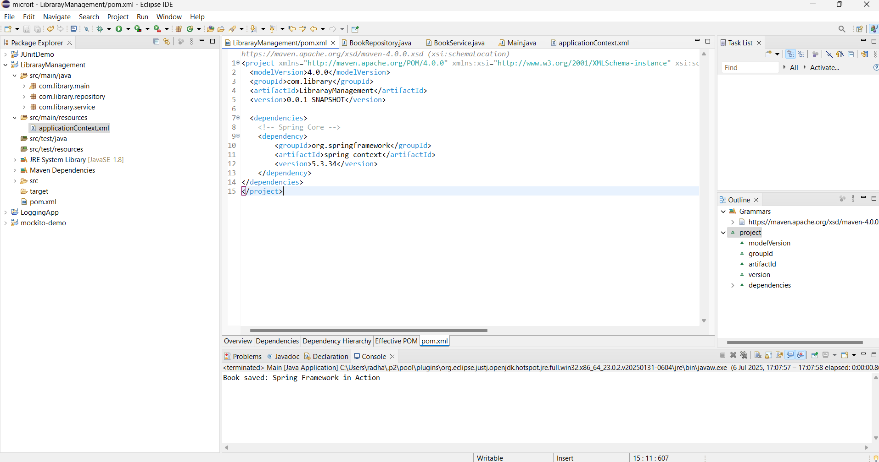
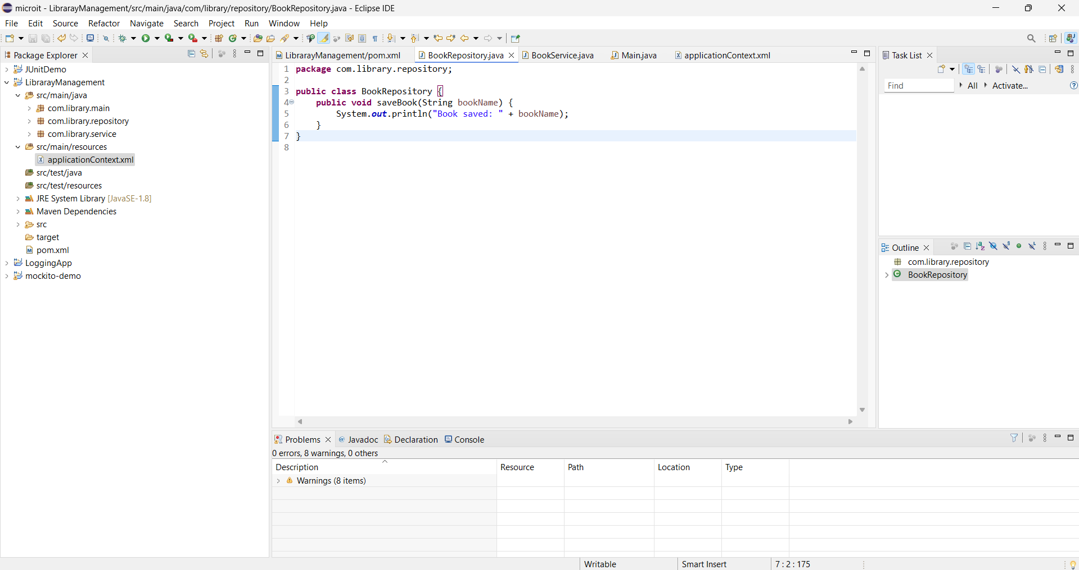
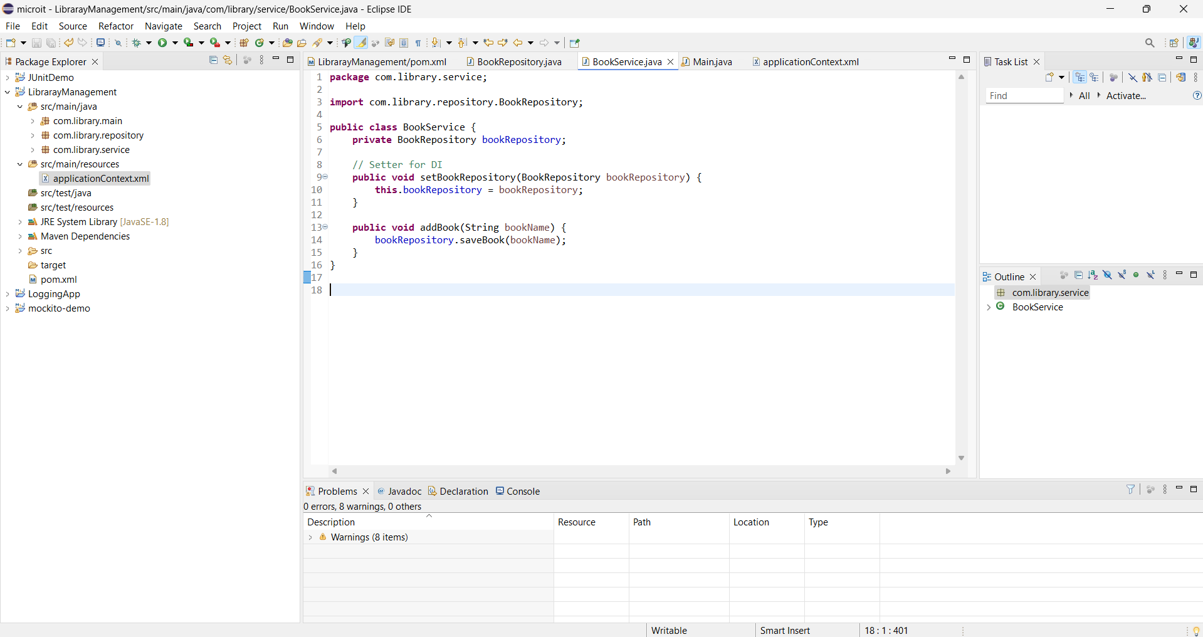

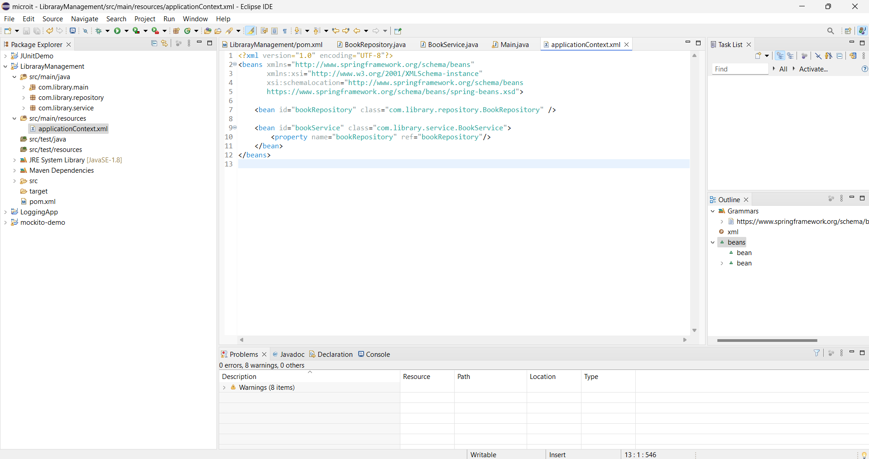
Output:
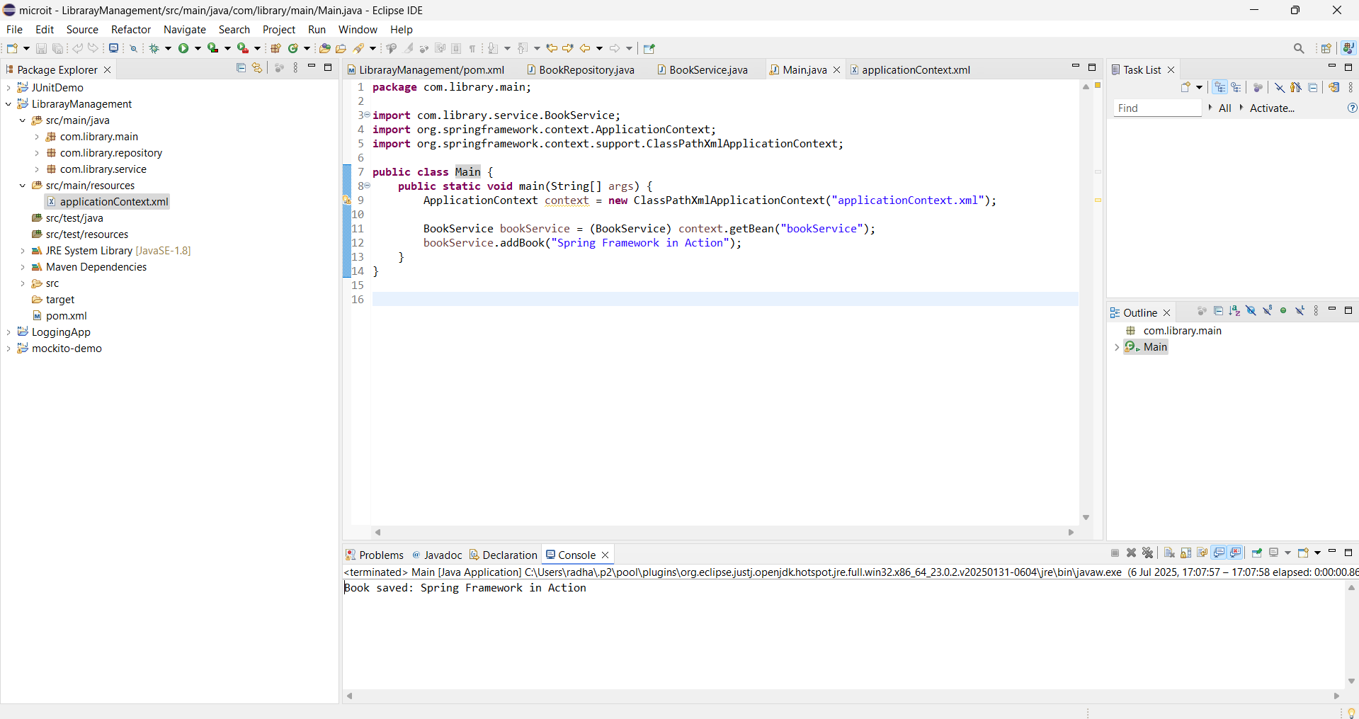

Exercise 2: Implementing Dependency Injection
Scenario:
In the library management application, you need to manage the dependencies between the BookService and BookRepository classes using Spring's IoC and DI.
Steps:
- Modify the XML Configuration:
  - Update applicationContext.xml to wire BookRepository into BookService.
- Update the BookService Class:
  - Ensure that BookService class has a setter method for BookRepository.
- Test the Configuration:
Run the LibraryManagementApplication main class to verify the dependency injection.
Solution:
Code:
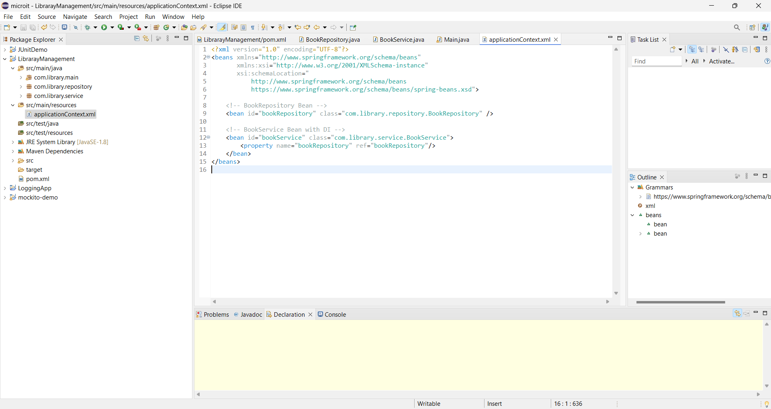
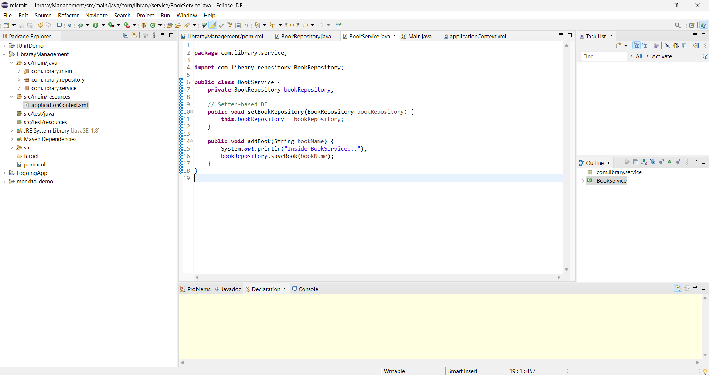

Output:
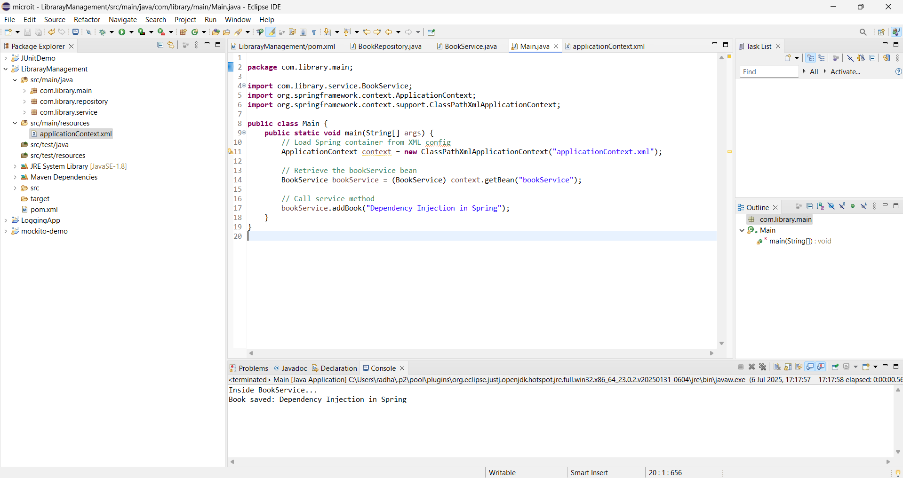

Exercise 4: Creating and Configuring a Maven Project
Scenario:
You need to set up a new Maven project for the library management application and add Spring dependencies.
Steps:
- Create a New Maven Project:
  - Create a new Maven project named LibraryManagement.
- Add Spring Dependencies in pom.xml:
  - Include dependencies for Spring Context, Spring AOP, and Spring WebMVC.
- Configure Maven Plugins:
  - Configure the Maven Compiler Plugin for Java version 1.8 in the pom.xml file.

Solution:
Code:
<project xmlns="http://maven.apache.org/POM/4.0.0"
xmlns:xsi="http://www.w3.org/2001/XMLSchema-instance"
xsi:schemaLocation="http://maven.apache.org/POM/4.0.0
http://maven.apache.org/xsd/maven-4.0.0.xsd">
<modelVersion>4.0.0</modelVersion>

<groupId>com.library</groupId>
<artifactId>LibraryManagement</artifactId>
<version>1.0-SNAPSHOT</version>
<packaging>jar</packaging>

<name>LibraryManagement</name>

<properties>
<maven.compiler.source>1.8</maven.compiler.source>
<maven.compiler.target>1.8</maven.compiler.target>
</properties>

<dependencies>
<dependency>
<groupId>org.springframework</groupId>
<artifactId>spring-context</artifactId>
<version>5.3.34</version>
</dependency>

<dependency>
<groupId>org.springframework</groupId>
<artifactId>spring-aop</artifactId>
<version>5.3.34</version>
</dependency>

<dependency>
<groupId>org.springframework</groupId>
<artifactId>spring-webmvc</artifactId>
<version>5.3.34</version>
</dependency>

<dependency>
<groupId>javax.servlet</groupId>
<artifactId>javax.servlet-api</artifactId>
<version>4.0.1</version>
<scope>provided</scope>
</dependency>
</dependencies>

<build>
<plugins>
<plugin>
<groupId>org.apache.maven.plugins</groupId>
<artifactId>maven-compiler-plugin</artifactId>
<version>3.8.1</version>
<configuration>
<source>1.8</source>
<target>1.8</target>
</configuration>
</plugin>
</plugins>
</build>
</project>

Handson1
Spring Data JPA - Quick Example
create table country(co_code varchar(2) primary key, co_name varchar(50));
insert into country values ('IN', 'India');
insert into country values ('US', 'United States of America');

OrmLearnApplication.java:
@SpringBootApplication
public class OrmLearnApplication {
private static final Logger LOGGER = LoggerFactory.getLogger(OrmLearnApplication.class);
private static CountryService countryService;

public static void main(String[] args) {
ApplicationContext context = SpringApplication.run(OrmLearnApplication.class, args);
countryService = context.getBean(CountryService.class);

LOGGER.info("Inside main");
testGetAllCountries();
}

private static void testGetAllCountries() {
LOGGER.info("Start");
List<Country> countries = countryService.getAllCountries();
LOGGER.debug("countries={}", countries);
LOGGER.info("End");
}
}
com.cognizant.ormlearn.service.CountryService:
@Service
public class CountryService {

@Autowired
private CountryRepository countryRepository;

@Transactional
public List<Country> getAllCountries() {
return countryRepository.findAll();
}
}
Command:
mvn clean package -Dhttp.proxyHost=proxy.cognizant.com -Dhttp.proxyPort=6050 -Dhttps.proxyHost=proxy.cognizant.com -Dhttps.proxyPort=6050 -Dhttp.proxyUser=123456
Output:
Inside main
Start
countries=[Country [code=IN, name=India], Country [code=US, name=United States of America]]
End
Hands on 4
Difference between JPA, Hibernate and Spring Data JPA
Java Persistence API (JPA)
- JSR 338 Specification for persisting, reading and managing data from Java objects
- Does not contain concrete implementation of the specification
- Hibernate is one of the implementation of JPA
Hibernate
- ORM Tool that implements JPA
Spring Data JPA
- Does not have JPA implementation, but reduces boiler plate code
- This is another level of abstraction over JPA implementation provider like Hibernate
- Manages transactions

